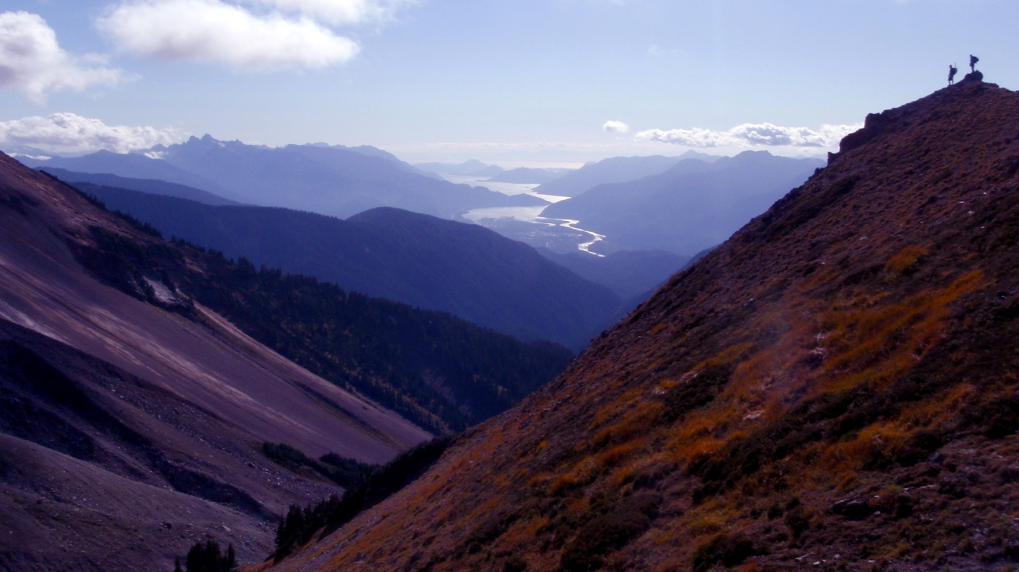
Stand Development Monitoring
Boundary TSA Summary

THIS SUMMARY IS BASED ON SURVEY DATA FROM 30 OR MORE POLYGONS. TAKE CARE IN DRAWING INFERENCES FROM THIS DATA.

This summary is from polygons surveyed in the Boundary TSA in 2009, 2010 and 2011. This summary is an example of the variety and depth of information that can be extracted from SDM data.

Currently, SDM field survey data is entered into an EXCEL spreadsheet template. This template provides an individual polygon data summary for immediate use. These spreadsheets are then loaded into the SDM ACCESS database. The database can be queried to produce an aggregated data summary like this one that includes data from multiple polygons within a TSA. The queries can be adjusted to extract data in various combinations depending on the user’s needs.

This summary is not an analysis; it provides limited interpretation of the data. Reports examining specific questions regarding productivity or that seek to explain trends and other behaviours can be constructed based on this data along with the use of other supporting tools or evidence.

Provincial and regional Forest Health and Silviculture staff can be asked to help with the interpretation of the information presented in the summaries and in the creation of more detailed reports.

Your input as comments and suggestions are needed to further develop these summaries. Please contact Harry.Kope@gov.bc.ca and provide your suggestions for improvement.

.
STAND DEVELOPMENT MONITORING - Boundary TSA Summary
Purpose and Audience – Data summaries can help statutory decision makers and operational foresters make informed decisions on stand development, TSR data package inputs, FSP renewals, and FFT activity priorities. They provide information on the growth and health of managed stands.
The Forest and Range Evaluation Program in conjunction with the provincial forest health program have designed an evaluation protocol (Stand Development Monitoring - SDM) that assesses the condition of post-free-growing managed stands by measuring stand attributes and the impact of biotic and abiotic damaging factors on stand health to determine whether these free-growing stands are meeting productivity expectations.
NOTE – This report provides summary information obtained from the surveyed polygons. Inferences from these summaries should be made cautiously.
This summary includes data on: Sample Summary Forest Health Stand Density Species Composition Site Index
SAMPLE SUMMARY
Polygon and polygon population attributes, and numbers and percentages of sampled live trees.
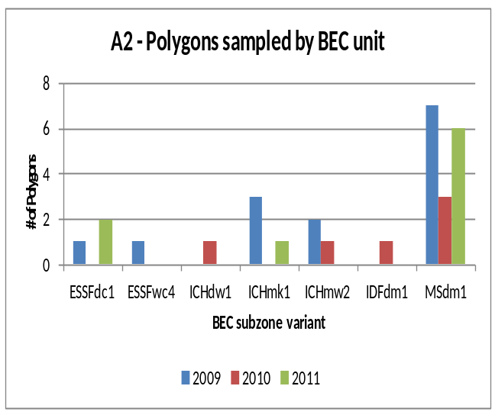
A1 – number of polygons sampled
Survey year: | 2009 | 2010 | 2011
DAB | 14 | 6 | 9

A3 - sampled polygon attributes
Attribute | nª | Mean | SD^{b} | Range
Polygon net area (ha) | 28 | 31.3 | 25.2 | 10 to 94
Stand Age (yrs) | 27 | 21.8 | 3.3 | 17 to 34
Harvest to Declaration (yrs) | 28 | 12.6 | 4.5 | 7 to 29
Planting to Declaration (yrs) | 27 | 10.6 | 4.5 | 3 to 26
Declaration to SDM (yrs) | 27 | 9.9 | 2.7 | -1 to 14
ª. Differing ‘n’ values indicate missing information for some polygons.
^{b}. SD - Standard Deviation

A4 - sample population coverage
TSA  polygon population  (n) | Total polygon population  area (ha) | Number Polygons  ≥5 ha  (n) | Population polygon area  ≥5 ha  (ha) | Number of polygons sampled  (n) | Sampling intensity by number of polygons | Area  sampled  (≥5 ha)  (ha) | Sampling intensity by area
315 | 5529 | 220 | 4989 | 2 | 0.9% | 163 | 3.3%

A5 - number and percentage of sampled total live trees
Tree species: | Ac | At | Ba | Bl | Cwi | Ep | Fdi | Hwi | Lw | Pli | Pw | Py | Se | Sx | Total
Number | 149 | 169 | 13 | 621 | 112 | 167 | 186 | 9 | 173 | 4152 | 2 | 1 | 195 | 452 | 6401
Percent | 2 | 3 | 0 | 10 | 2 | 3 | 3 | 0 | 3 | 65 | 0 | 0 | 3 | 7 | 100
X1 - Tree Species Abbreviations
Ac – Poplar Hwi – Western Hemlock (Interior)
Act – Black Cottonwood Lw – Western Larch
Ba –Amabilis Fir Pli – Lodgepole Pine (Interior)
Bl –Subalpine Fir Pw –Western white Pine
Cwi – Western red Cedar (Interior) Py – Ponderosa Pine
Ep – Common Paper Birch Se – Engelmann Spruce
Fdi – Douglas-fir (Interior) Sx – Spruce hybrid
Yc – Yellow Cedar

FOREST HEALTH
Forest Health is assessed using the SDM damage criteria for mid-rotation stands (see Appendix 1). The damage criteria establish forest health threshold tolerances identifying unacceptable and damaged trees, which are labelled pest affected trees. In the Strahcona TSA the pathogen most recorded was Hemlock dwarf mistletoe (DMH); the animal damage was Elk (AE); the abiotic damage was Tree competition (VT).
B1 – average stems per ha by forest health status
X2 – tree layers
Layer 1 >12.5 cm dbh
Layer 2 7.5 to 12.5 cm dbh
Layer 3 >1.3 m in height to 7.49 cm dbh
District | Live Acceptable Trees (sph) | Live Unacceptable Trees (sph) | Dead Unacceptable Trees (sph) | Total Stemsª (sph)
DAB | 3989 | 426 | 164 | 4579
ª For forest health purposes total stems equals all live trees plus all dead trees.
X3 – forest health abbreviations
DSG – Western gall rust IWS – White Pine weevil VT – Tree Competition
DRA –Armillaria root disease IBM – Mountain Pine beetle NY – Snow press
DFM – White Pine blister rust IWP – Lodgepole Pine terminal weevil TL – Logging damage
DSC – Comandra blister rust IDB – Two-year budworm VS – Shrub competition
DSS – Stalactiform blister rust IDX – Large Aspen tortix TM – Mechanical damage
DSA – Atropelis canker AM – Moose AD - Deer VP – Vegetation press
DSP – Cytospora canker AP – Porcupine AH - Hare UBT – Broken top
IWW – Warren’s root collar weevil AS – Squirrel AC - Cattle UK - Fork
IDN – Birch leaf miners AB – Bear AE - Elk U - Unknown
B2 - forest health factors detected
(Brackets are the number of plots with a specific forest health factor. Plots =290)
Pathogen DSG (76) DRA (20) DFM (17) DSC (13) DSS (8) DSA (3) DSP (2)
Insect IWW (5) IDN (4) IWS (4) IBM (2) IDB (1) IDX (1)
Animal AM (24) AP (21) AS (14) AB (11) AD (8) AH (5) AC (2) AE (2)
Abiotic VT (49) NY (46) TL (6) VS (5) TM (4) VP (4) UBT (2) UK (2)
Unknown U (49)

B3 - incidence of forest health factor by bec
BEC | Tree Layer | Total Stems | Acceptable Trees |  | Unacceptable Trees |  |  |  |  | Percent incidence^{c} of Forest Health Factor^{d} for each tree layer
 |  |  |  |  | Live |  | Dead
BEC | Tree Layer | Total Stems | n | (%^{b}) | n | (%^{b}) | n | (%^{b}) | DSG |  | DRA | DFM | DSC | DSS | AM | AP | AS | AB | VT | NY | Other | U
ESSFdc1 | 1 | 45 | 44 |  | 1 |  | 0 |  | - |  | - | - | - | - | - | - | - | - | - | - | 2.2 | -
 | 2 | 122 | 115 |  | 4 |  | 3 |  | 0.8 |  | 0.8 | - | - | - | - | - | - | - | - | - | 4.1 | -
 | 3 | 386 | 370 |  | 11 |  | 5 |  | 1.0 |  | - | - | - | - | - | 0.3 | - | - | - | 0.3 | 2.6 | -
 |  | 553 | 529 | (95.7) | 16 | (2.9) | 8 | (1.4) | 0.9 |  | 0.2 | 0.0 | 0.0 | 0.0 | 0.0 | 0.2 | 0.0 | 0.0 | 0.0 | 0.2 | 2.9 | 0.0
ESSFwc4 | 1 | 6 | 5 |  | 1 |  | 0 |  | - |  | - | - | - | - | - | - | - | - | - | 16.7 | - | -
 | 2 | 56 | 53 |  | 3 |  | 0 |  | - |  | - | - | - | - | - | - | - | - | - | 5.4 | - | -
 | 3 | 210 | 197 |  | 11 |  | 2 |  | - |  | - | - | - | - | 0.5 | - | - | 0.5 | - | 3.3 | 1.9 | -
 |  | 272 | 255 | (93.8) | 15 | (5.5) | 2 | (0.7) | 0.0 |  | 0.0 | 0.0 | 0.0 | 0.0 | 0.4 | 0.0 | 0.0 | 0.4 | 0.0 | 4.0 | 1.5 | 0.0
ICHdw1 | 1 | 4 | 4 |  | 0 |  | 0 |  | - |  | - | - | - | - | - | - | - | - | - | - | - | -
 | 2 | 31 | 25 |  | 5 |  | 1 |  | - |  | - | - | - | - | - | - | - | - | - | - | 19.4 | -
 | 3 | 246 | 190 |  | 41 |  | 15 |  | 0.8 |  | 0.8 | - | - | - | 0.4 | - | - | - | 0.4 | - | 20.3 | -
 |  | 281 | 219 | (77.9) | 46 | (16.4) | 16 | (5.7) | 0.7 |  | 0.7 | - | - | - | 0.4 | - | - | - | 0.4 | - | 19.9 | -
ICHmk1 | 1 | 79 | 69 |  | 10 |  | 0 |  | 1.3 |  | - | - | - | - | - | 6.3 | - | 2.5 | - | 1.3 | 1.3 | -
 | 2 | 141 | 135 |  | 5 |  | 1 |  | 2.1 |  | - | - | - | - | - | - | - | - | - | 1.4 | 0.7 | -
 | 3 | 404 | 347 |  | 23 |  | 34 |  | 2.0 |  | 0.5 | 0.2 | 0.5 | 0.2 | - | 0.2 | - | - | 4.2 | 2.7 | 3.5 | -
 |  | 624 | 551 | (88.3) | 38 | (6.1) | 35 | (5.6) | 1.9 |  | 0.3 | 0.2 | 0.3 | 0.2 | 0.0 | 1.0 | 0.0 | 0.3 | 2.7 | 2.2 | 2.6 | 0.0
ICHmw2 | 1 | 21 | 17 |  | 4 |  | 0 |  | - |  | - | - | - | - | - | - | - | 4.8 | - | - | 4.8 | -
 | 2 | 148 | 129 |  | 12 |  | 7 |  | - |  | 2.0 | - | 0.7 | 0.7 | - | 0.7 | - | 2.7 | - | 2.0 | 4.1 | -
 | 3 | 617 | 531 |  | 71 |  | 15 |  | 2.8 |  | 0.5 | - | 0.3 | 0.2 | 0.8 | - | - | 0.3 | 0.3 | 4.5 | 4.2 | -
 |  | 786 | 677 | (86.1) | 87 | (11.1) | 22 | (2.8) | 2.2 |  | 0.8 | 0.0 | 0.4 | 0.3 | 0.6 | 0.4 | 0.0 | 0.9 | 0.3 | 3.0 | 4.2 | 0.0

B3 - incidence of forest health factor by bec
BEC | Tree Layer | Total Stems | Acceptable Trees |  | Unacceptable Trees |  |  |  |  | Percent incidence^{c} of Forest Health Factor^{d} for each tree layer
 |  |  |  |  | Live |  | Dead
BEC | Tree Layer | Total Stems | n | (%^{b}) | n | (%^{b}) | n | (%^{b}) | DSG |  | DRA | DFM | DSC | DSS | AM | AP | AS | AB | VT | NY | Other | U
IDFdm1 | 1 | 2 | 2 |  | 0 |  | 0 |  | - |  | - | - | - | - | - | - | - | - | - | - | - | -
 | 2 | 22 | 18 |  | 4 |  | 0 |  | 4.5 |  | - | - | - | 4.5 | - | - | - | - | - | 9.1 | - | -
 | 3 | 245 | 174 |  | 57 |  | 14 |  | 8.2 |  | - | 0.4 | - | 0.8 | 1.6 | - | - | - | 4.1 | 11.8 | 2.0 | -
 |  | 269 | 194 | (72.1) | 61 | (22.7) | 14 | (5.2) | 7.8 |  | 0.0 | 0.4 | 0.0 | 1.1 | 1.5 | 0.0 | 0.0 | 0.0 | 3.7 | 11.5 | 1.0 | 0.0
MSdm1 | 1 | 106 | 91 |  | 14 |  | 1 |  | 1.9 |  | - | - | 0.9 | - | - | 1.9 | - | 3.8 | - | 0.9 | 4.7 | -
 | 2 | 699 | 945 |  | 47 |  | 9 |  | 1.6 |  | 0.3 | 0.4 | 0.3 | 0.1 | - | 1.4 | 0.4 | 0.3 | - | 0.1 | 3.9 | 0.1
 | 3 | 3022 | 2625 |  | 271 |  | 126 |  | 1.9 |  | 0.3 | 1.2 | 0.5 | 0.1 | 0.9 | 0.4 | 1.0 | - | 4.4 | 0.1 | 2.3 | -
 |  | 3827 | 3359 | (87.8) | 332 | (8.7) | 136 | (3.6) | 1.8 |  | 0.3 | 1.0 | 0.5 | 0.1 | 0.7 | 0.7 | 0.9 | 0.2 | 3.2 | 0.2 | 2.5 | 0.0
a. Averages on a per ha basis b. For forest health purposes total stems equals total live plus total dead c. Percent of the total stems d. Only the top FHF are listed, the Other column contains the minor FHF not listed.
B4 - incidence of forest health factor by tree species
Tree Species | Tree Layer | Total Stems | Acceptable Trees |  |  | Unacceptable Trees |  |  |  |  |  |  |  |  |  |  |  | Percent incidence^{c} of Forest Health Factor^{d} for each tree layer
 |  |  |  |  |  | Live |  |  | Dead
Tree Species | Tree Layer | Total Stems | n | (%^{b}) | n |  | (%^{b}) | n |  | (%^{b}) | DSG |  | DRA |  | DFM |  | DSC |  | DSS | AM | AP | AS | AB | VT | NY | Other | U
At | 1 | 6 | 6 |  | 0 |  |  | 0 |  |  | - |  | - |  | - |  | - |  | - | - | - | - | - | - | - | - | -
 | 2 | 25 | 25 |  | 0 |  |  | 0 |  |  | - |  | - |  | - |  | - |  | - | - | - | - | - | - | - | - | -
 | 3 | 279 | 241 |  | 24 |  |  | 14 |  |  | - |  | - |  | - |  | - |  | - | 0.4 |  |  |  | 3.3 | 0.4 | 11.6 | -
 |  | 310 | 272 | (87.7) | 24 |  | (7.7) | 14 |  | (4.5) | 0.0.0 |  | 0.0 |  | 0.0 |  | 0.0 |  | 0.0 | 0.4 | 0.0 | 0.0 | 0.0 | 2.9 | 0.4 | 10.3 | 0.0
Ba | 2 | 2 | 2 |  | 0 |  |  | 0 |  |  | - |  | - |  | - |  | - |  | - | - | - | - | - | - | - | - | -
 | 3 | 11 | 11 |  | 0 |  |  | 0 |  |  | - |  | - |  | - |  | - |  | - | - | - | - | - | - | - | - | -
 |  | 13 | 13 | (100.0) | 0 |  | (0.0) | 0 |  | (0.0) | 0.0 |  | 0.0 |  | 0.0 |  | 0.0 |  | 0.0 | 0.0 | 0.0 | 0.0 | 0.0 | 0.0 | 0.0 | 0.0 | 0.0
Bl | 1 | 9 | 9 |  | 0 |  |  | 0 |  |  | - |  | - |  | - |  | - |  | - | - | - | - | - | - | - | - | -
 | 2 | 73 | 71 |  | 2 |  |  | 0 |  |  | - |  | - |  | - |  | - |  | - | - | - | 1.4 | - | - | - | 1.4 | -
 | 3 | 540 | 530 |  | 9 |  |  | 1 |  |  | - |  | - |  | - |  | - |  | - | 0.4 | - | - | - | 0.2 | 0.8 | 0.6 | -
 |  | 622 | 610 | (98.1) | 11 |  | (1.8) | 1 |  | (0.2) | 0.0 |  | 0.0 |  | 0.0 |  | 0.0 |  | 0.0 | 0.3 | 0.0 | 0.2 | 0.0 | 0.2 | 0.7 | 0.7 | 0.0
Cwi | 1 | 4 | 3 |  | 1 |  |  | 0 |  |  | - |  | - |  | - |  | - |  | - | - | - | - | - | - | 33.3 | - | -
 | 2 | 9 | 8 |  | 1 |  |  | 0 |  |  | - |  | - |  | - |  | - |  | - | - | - | - | - | - | 12.5 | - | -
 | 3 | 99 | 94 |  | 5 |  |  | 0 |  |  | - |  | - |  | - |  | - |  | - | - | - | - | - | - | 3.2 | 2.1 | -
 |  | 112 | 103 | (93.8) | 7 |  | (6.3) | 0 |  | (0.0) | 0.0 |  | 0.0 |  | 0.0 |  | 0.0 |  | 0.0 | 0.0 | 0.0 | 0.0 | 0.0 | 0.0 | 4.8 | 1.9 | 0.0
Ep | 1 | 1 | 1 |  | 0 |  |  | 0 |  |  | - |  | - |  | - |  | - |  | - | - | - | - | - | - | - | - | -
 | 2 | 14 | 11 |  | 3 |  |  | 0 |  |  | - |  | - |  | - |  | - |  | - | - | - | - | - | - | - | 27.3 | -
 | 3 | 157 | 116 |  | 36 |  |  | 5 |  |  | - |  | - |  | - |  | - |  | - | 1.7 | - | - | - | 1.7 | - | 31.0 | -
 |  | 172 | 128 | (74.4) | 39 |  | (22.7) | 5 |  | (2.9) | 0.0 |  | 0.0 |  | 0.0 |  | 0.0 |  | 0.0 | 1.6 | 0.0 | 0.0 | 1.6 | 0.8 | 0.0 | 30.5 | 0.0
Fdi | 1 | 8 | 8 |  | 0 |  |  | 0 |  |  | - |  | - |  | - |  | - |  | - | - | - | - | - | - | - | - | -
 | 2 | 16 | 15 |  | 1 |  |  | 0 |  |  | - |  | - |  | - |  | - |  | - | - | - | - | - | - | - | 6.7 | -
 | 3 | 164 | 151 |  | 11 |  |  | 2 |  |  | - |  | 0.7 |  | - |  | - |  | - | - | - | - | - | 1.3 | 2.6 | 4.0 | -
 |  | 188 | 174 | (92.6) | 12 |  | (6.4) | 2 |  | (1.1) | 0.0 |  | 0.6 |  | 0.0 |  | 0.0 |  | 0.0 | 0.0 | 0.0 | 0.0 | 0.0 | 1.1 | 2.3 | 4.0 | 0.0
Hw | 2 | 2 | 2 |  | 0 |  |  | 0 |  |  | - |  | - |  | - |  | - |  | - | - | - | - | - | - | - | - | -
 | 3 | 7 | 6 |  | 1 |  |  | 0 |  |  | - |  | - |  | - |  | - |  | - | - | - | - | - | - | - | 16.7 | -
 |  | 9 | 8 | (88.9) | 1 |  | (11.1) | 0 |  | (0.0) | 0.0 |  | 0.0 |  | 0.0 |  | 0.0 |  | 0.0 | 0.0 | 0.0 | 0.0 | 0.0 | 0.0 | 0.0 | 12.5 | 0.0
Lw | 1 | 7 | 7 |  | 0 |  |  | 0 |  |  | - |  | - |  | - |  | - |  | - | - | - | - | - | - | - | - | -
 | 2 | 25 | 22 |  | 3 |  |  | 0 |  |  | - |  | - |  | 13.6 |  | - |  | - | - | - | - | - | - | - | - | -
 | 3 | 151 | 97 |  | 44 |  |  | 10 |  |  | - |  | 5.2 |  | 38.1 |  | - |  | - | - | - | - | - | 6.2 | 1.0 | 5.2 | -
 |  | 183 | 126 | )68.9) | 47 |  | (25.7) | 10 |  | (5.5) | 0.0 |  | 4.0 |  | 31.7 |  | 0.0 |  | 0.0 | 0.0 | 0.0 | 0.0 | 0.0 | 4.8 | 0.8 | 4.0 | 0.0
Pli | 1 | 187 | 160 |  | 26 |  |  | 1 |  |  | 1.9 |  | - |  | - |  | 0.6 |  | - | - | 5.6 | - | 3.1 | - | 1.3 | 4.4 | -
 | 2 | 906 | 826 |  | 61 |  |  | 19 |  |  | 1.9 |  | 0.7 |  | - |  | 0.4 |  | 0.4 | - | 1.3 | 0.2 | 0.7 | - | 0.8 | 3.0 | -
 | 3 | 3242 | 2731 |  | 341 |  |  | 170 |  |  | 4.0 |  | 0.3 |  | - |  | 0.7 |  | 0.3 | 1.2 | 0.5 | 1.1 | 0.1 | 5.2 | 2.3 | 3.0 | -
 |  | 4335 | 3717 | (85.7) | 428 |  | (9.9) | 190 |  | (5.1) | 3.4 |  | 0.4 |  | 0.0 |  | 0.6 |  | 0.3 | 0.9 | 0.9 | 0.9 | 0.3 | 3.8 | 1.9 | 3.1 | 0.0

B4 - incidence of forest health factor by tree species
Tree Species | Tree Layer | Total Stems | Acceptable Trees |  |  | Unacceptable Trees |  |  |  |  |  |  |  |  |  |  |  | Percent incidence^{c} of Forest Health Factor^{d} for each tree layer
 |  |  |  |  |  | Live |  |  | Dead
Tree Species | Tree Layer | Total Stems | n | (%^{b}) | n |  | (%^{b}) | n |  | (%^{b}) | DSG |  | DRA |  | DFM |  | DSC |  | DSS | AM | AP | AS | AB | VT | NY | Other | U
Pw | 2 | 1 | 1 |  | 0 |  |  | 0 |  |  | - |  | - |  | - |  | - |  | - | - | - | - | - | - | - | - | -
 | 3 | 2 | 2 |  | 0 |  |  | 0 |  |  | - |  | - |  | - |  | - |  | - | - | - | - | - | - | - | - | -
 |  | 3 | 3 | (100.0) | 0 |  | (0.0) | 0 |  | (0.0) | 0.0 |  | 0.0 |  | 0.0 |  | 0.0 |  | 0.0 | 0.0 | 0.0 | 0.0 | 0.0 | 0.0 | 0.0 | 0.0 | 0.0
Se | 1 | 24 | 23 |  | 1 |  |  | 0 |  |  | - |  | - |  | - |  | - |  | - | - | - | - | - | - | - | 4.3 | -
 | 2 | 50 | 44 |  | 6 |  |  | 0 |  |  | - |  | - |  | - |  | - |  | - | - | - | - | - | - | 4.5 | 9.1 | -
 | 3 | 123 | 117 |  | 4 |  |  | 2 |  |  | 1.7 |  | - |  | - |  | - |  | - | - | - | - | 0.9 | - | 0.9 | 1.7 | -
 |  | 197 | 184 | (93.4) | 11 |  | (5.6) | 2 |  | (1.0) | 0.0 |  | 1.1 |  | 0.0 |  | 0.0 |  | 0.0 | 0.0 | 0.0 | 0.0 | 0.5 | 0.0 | 1.6 | 3.8 | 0.0
Sx | 1 | 13 | 13 |  | 0 |  |  | 0 |  |  | - |  | - |  | - |  | - |  | - | - | - | - | - | - | - | - | -
 | 2 | 96 | 92 |  | 3 |  |  | 1 |  |  | - |  | - |  | - |  | - |  | - | - | - | - | - | - | 1.1 | 3.3 | -
 | 3 | 351 | 337 |  | 7 |  |  | 7 |  |  | - |  | 0.3 |  | - |  | - |  | - | - | - | - | - | 0.3 | 0.3 | 3.3 | -
 |  | 460 | 442 | (96.1) | 10 |  | (2.2) | 8 |  | (1.7) | 0.0 |  | 0.2 |  | 0.0 |  | 0.0 |  | 0.0 | 0.0 | 0.0 | 0.0 | 0.0 | 0.2 | 0.5 | 3.2 | 0.0
ª Percent based on total stems (live and dead); ^{b} Percent incidence of the total stems of a layer for each FHF; ^{c} Only the top FHF are listed, the Other column contains the minor FHF not listed.

STAND DENSITY
To produce a free-growing crop of trees a stand is managed to the target stocking level of well-spaced, preferred and acceptable species. Over time, changes in stand density may reflect tree competition, mortality due to pests, stand treatments, natural ingress or other influences.
C1 - number of polygons with changes to stand density
Change in Total Stand Density  Total Trees (n=5) |  | Change in Stocking Density  Well-Spaced Trees (n= 5)
Decreasing | 16 | Decreasing | 13
Increasing | 12 | Increasing | 14
Data missing | 1 | Data missing | 1
 |  | Unchanged | 1

C2 - stand density attributes by bec – pre-sdm and at sdm
 | ESSFdc |  | ESSFwc4 |  | ICHdw1 |  | ICHmk1
 | N | Mean (sph) | N | Mean (sph) | N | Mean (sph) | N | Mean (sph)
Total Density pre-SDM (sph) | 3 | 4290 | 1 | 2600 | 1 | 5070 | 4 | 3697
Total Density at SDM (sph) | 3 | 3633 | 1 | 5400 | 1 | 5300 | 4 | 2945
Change in Total Density (sph) | 3 | -657 | 1 | 2800 | 1 | 230 | 4 | -752
Change in Total Density (%) | 3 | -15.3 | 1 | 116.7 | 1 | 4.5 | 4 | -20.3
WS density pre-SDM (sph) | 3 | 937 | 1 | 1100 | 1 | 1180 | 4 | 1152
WS density at SDM (sph) | 3 | 1107 | 1 | 1460 | 1 | 1180 | 4 | 1005
Change in WS density (sph) | 3 | 170 | 1 | 360 | 1 | 0 | 4 | -147
Change in WS density (%) | 3 | 18.1 | 1 | 32.7 | 1 | 0.0 | 4 | -12.8
FG density pre-SDM(sph) | 3 | 871 | 1 | 1100 | 1 | 1050 | 4 | 1106
FG density at SDM (sph) | 3 | 1107 | 1 | 1400 | 1 | 1180 | 4 | 995

 | ICHmw2 |  | IDFdm1 |  | MSdm1 |  | ALL
 | N | Mean (sph) | N | Mean (sph) | N | Mean (sph) | N | Mean (sph)
Total Density pre-SDM (sph) | 3 | 5835 | 1 | 5283 | 16 | 5093 | 29 | 4814
Total Density at SDM (sph) | 3 | 5093 | 1 | 5100 | 15 | 4600 | 28 | 4384
Change in Total Density (sph) | 3 | -741 | 1 | -183 | 15 | -361 | 28 | -349
Change in Total Density (%) | 3 | -12.7 | 1 | -3.7 | 15 | -7.1 | 28 | -7.2
WS density pre-SDM (sph) | 3 | 1181 | 1 | 1000 | 16 | 1114 | 29 | 1106
WS density at SDM (sph) | 3 | 1213 | 1 | 880 | 15 | 1131 | 28 | 1124
Change in WS density (sph) | 3 | 32 | 1 | -120 | 15 | 12 | 28 | 16
Change in WS density (%) | 3 | 2.7 | 1 | -12.0 | 15 | 1.1 | 28 | 1.5
FG density pre-SDM(sph) | 3 | 1036 | 1 | 983 | 16 | 991 | 29 | 1005
FG density at SDM (sph) | 3 | 1213 | 1 | 860 | 16 | 1125 | 29 | 1119

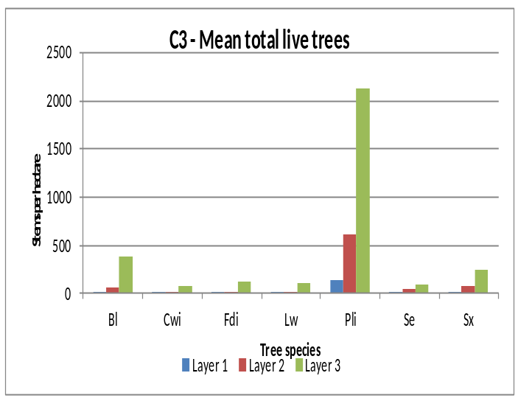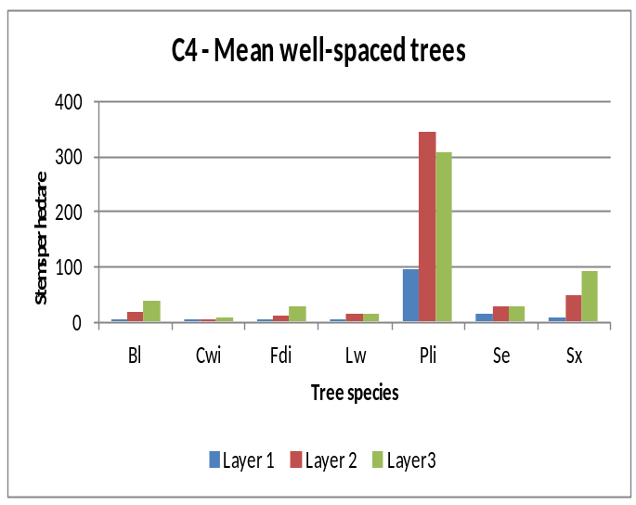

SPECIES COMPOSITION
Inventory labels are condensed representations of several stand attributes that describe conditions at the time of assessment. These attributes include leading, secondary and minor tree species by percentage class (usually rounded to the nearest 10%), average age and height of the dominant and co-dominant trees, a site index estimate, an estimate of crown closure, and the total trees per hectare. Inventory labels provide inputs used by the TASS stand model and by timber supply analysts projecting future stand development for timber supply purposes.

D1 - change in leading species between pre-sdm and sdm assessments
At DEC
ESSFdc1 ESSFwc4 ICHdw1 ICHmk1 ICHmw2 IDFdm1
SDM Bl Lw Pli Se Sx Bl Lw Pli Se Sx Bl Lw Pli Se Sx Bl Lw Pli Se Sx Bl Lw Pli Se Sx Bl Lw Pli Se Sx
Bl 0 - - - 1 0 - - - - 0 - - - - 0 - - - - 0 - - - - 0 - - - -
Lw - 0 - - - - 1 - - - - 0 - 1 - - 0 1 - - - 0 - - - - 0 - - -
Pli - - 1 - - - - 0 - - - - 0 - - - - 2 - 1 - - 3 - - - - 1 - - -
Se - - - 1 - 1 - - 0 - - - - 0 - - - - 0 - - - - 0 - - - - 0 -
Sx - - - - 0 - - - - 0 - - - - 1 - - - - 0 - - - - 0 - - - - 0
All - - 1 1 1 - 1 - - - - - - - 1 - - 3 - 1 - - 3 - - - - 1 - -

MSdm1 ALL
SDM Bl Lw Pli Se Sx Bl Lw Pli Se Sx
Bl 0 - - - - 0 - - - 1
Lw - 0 - - - - 0 1 - -
Pli - - 14 - 1 - - 21 - 2
Se - - - 0 - 1 - - 1 -
Sx - - - - 0 - - - - 1
All - - 14 - 1 1- 0 22 1 4
(Shaded values indicate those polygons where the leading species has NOT changed)
(In this TSA, no change in leading species was found in 23 (82%) of the 28 polygons sampled.)

D2 – tree species and layer used to calculate mean basal area
 | Number of Trees |  |  |  |  |  | Mean Polygon BA (m²/ha)
Tree spp. | Layer 1 |  | Layer 2 |  | All | Tree spp. | Layer 1 |  | Layer 2 |  | All
 | Live | Dead | Live | Dead |  |  | Live | Dead | Live | Dead
Bl | 3 |  | 35 |  | 44 | Bl | 0.03 |  | 0.17 |  | 0.20
Fdi | 8 |  | 12 |  | 21 | Fdi | 0.15 |  | 0.06 |  | 0.21
Lw | 4 |  | 19 |  | 28 | Lw | 0.04 |  | 0.10 |  | 0.14
Pli | 85 |  | 392 | 6 | 570 | Pli | 0.91 |  | 1.90 | 0.03 | 2.84
Se | 17 |  | 14 |  | 57 | Se | 0.22 |  | 0.08 |  | 0.30
Sx | 15 |  | 78 | 1 | 94 | Sx | 0.16 |  | 0.39 | 0.01 | 0.55
Minor spp | 6 |  | 37 | 1 | 51 | Minor spp | 0.12 |  | 0.15 |  | 0.28
Total | 138 |  | 587 | 8 | 733 | Total | 1.65 |  | 2.85 | 0.04 | 4.53
% by layer | 18.8 |  | 80.1 | 1.1 |  | % by layer | 36.4 |  | 62.9 | 0.9

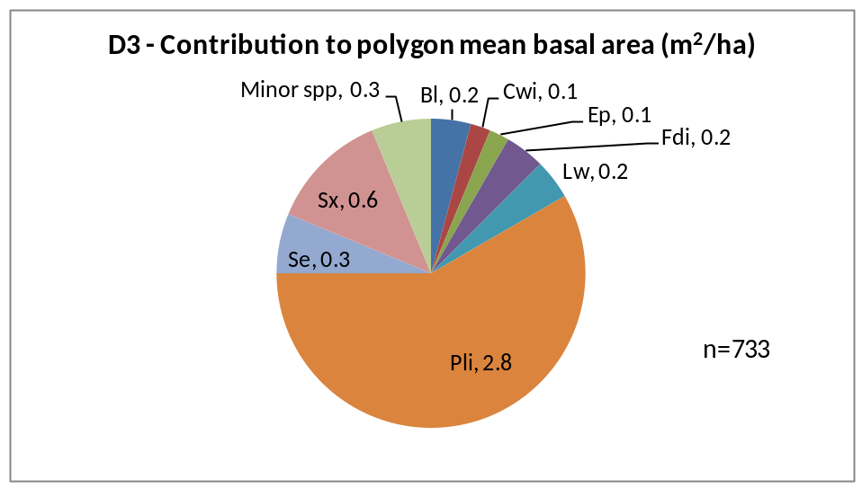

SITE INDEX
Site index was estimated using the growth intercept method. The estimates are the mean values of all available trees for that species in a BEC. Many stands do not have site index estimates recorded prior to the SDM survey.

E1 - mean site index estimate for dominant conifer species
 | Ba |  | Fdi |  |  | Hwi |  |  | Lw |  | Pli |  | Se
BEC | N | Mean | N | Mean |  | N | Mean | N |  | Mean | N | Mean | N | Mean
ESSFdc1 | - | - | - | - |  | - | - | - |  | - | 12 | 16.8 | 7 | 23.0
ESSFwc4 | 3 | 19.9 | - | - |  | - | - | - |  | - | 2 | 18.0 | 5 | 24.4
ICHdw1 | - | - | 1 | 17.7 |  | 1 | 21.7 | 1 |  | 23.9 | 3 | 22.3 | - | -
ICHmk1 | - | - | 1 | 19.8 |  | - | - | 2 |  | 26.5 | 26 | 22.7 | - | -
ICHmw2 | - | - | 1 | 7.1 |  | - | - | - |  | - | 26 | 19.5 | 3 | 25.1
IDFdm1 | - | - | 1 | 19.8 |  | - | - | 1 |  | 28.4 | 8 | 19.4 | - | -
MSdm1 | 1 | 17.8 | 4 | 20.0 |  | - | - | 14 |  | 23.3 | 135 | 21.1 | - | -
ALL | 4 | 19.4 | 8 | 18.0 |  | 1 | 21.7 | 18 |  | 23.9 | 212 | 20.8 | 15 | 23.9
 | Sx |  | Total
BEC | N | Mean | N
ESSFdc1 | 10 | 18.6 | 29
ESSFwc4 | - | - | 10
ICHdw1 | 3 | 18.8 | 9
ICHmk1 | 10 | 22.4 | 39
ICHmw2 | - | - | 30
IDFdm1 | - | - | 10
MSdm1 | 23.9 | 23.7 | 157
ALL |  | 20.7 | 284

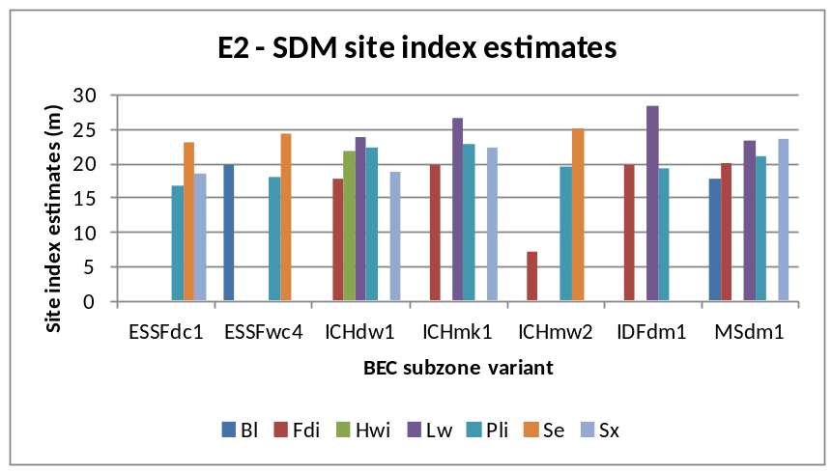
APPENDIX 1
BEC codes - http://www.for.gov.bc.ca/hre/becweb/index.html
Conifer pest codes - http://www.for.gov.bc.ca/hfp/health/fhdata/FS747%20conifer%2020111003.pdf
Conifer Tree Species codes http://www.for.gov.bc.ca/his/results/webhelp/index.htm
Deciduous pest codes - http://www.for.gov.bc.ca/hfp/health/fhdata/FS747%20deciduous%2020111003.pdf
SDM damage criteria - http://www.for.gov.bc.ca/hfp/silviculture/Surveys/SDM_Damage_Criteria_Feb_12_2010(2).pdf
SDM field cards - http://www.for.gov.bc.ca/ftp/HFP/external/!publish/FREP/indicators/FS%201357-SDMCard%20March%2012%2009.pdf
SDM survey protocol http://www.for.gov.bc.ca/ftp/HFP/external/!publish/FREP/Indicators/SDM%20Protocol%202011.pdf
Stocking Standards tables - http://www.for.gov.bc.ca/hfp/silviculture/stocking_stds.htm

APPENDIX 2
The complete list of openings, and polygons used in this report are listed here

TSA=Boundary; Survey Year=2009 District=DAB
MAPSHEET | POLYGON | Year Logged (Smry) | BEC (Smry) | Polygon Net Area (Popn) | Leading Spp @ SDM (Smry) | Stand Age (Calc) | Total Live Trees @ SDM (Smry) | WS @ SDM (Smry) | SI @ SDM (Smry)
82E 018 019 | 665 | 1983 | ICHmk1 | 12.0 | Pli | 26 | 2840 | 820 | 22.2
82E 020 013 | 8 | 1984 | ESSFwc4 | 13.0 | Bl | 25 | 5400 | 1460 | 20.4
82E 020 043 | A | 1991 | ICHmw2 | 26.7 | Pli | 18 | 6260 | 1520 | 19.4
82E 030 028 | A | 1989 | ICHmw2 | 33.9 | Pli | 20 | 3460 | 860 | 18.9
82E 037 002 | 229 | 1975 | ESSFdc1 | 16.0 | Se | 34 | 2660 | 1040 | 19.8
82E 057 040 | C | 1989 | MSdm1 | 20.0 | Pli | 20 | 1920 | 1040 | 18.9
82E 057 041 | A | 1989 | MSdm1 | 72.2 | Pli | 20 | 5940 | 1240 | 20.3
82E 057 044 | A | 1990 | MSdm1 | 24.0 | Pli | 19 | 3220 | 1300 | 19.2
82E 066 009 | 206 | 1983 | MSdm1 | 12.7 | Pli | 26 | 3280 | 1180 | 22.8
82E 066 112 | A | 1989 | ICHmk1 | 90.8 | Pli | 20 | 3360 | 1140 | 24.8
82E 066 131 | A | 1992 | MSdm1 | 56.9 | Pli | 17 | 8800 | 1320 | 21.5
82E 066 134 | A | 1989 | MSdm1 | 17.7 | Pli | 20 | 7420 | 1340 | 19.3
82E 066 157 | A | 1992 | MSdm1 | 27.9 | Pli | 17 | 4920 | 1280 | 21.0
82E 087 009 | 718 | 1986 | ICHmk1 | 58.0 | Pli | 23 | 3520 | 1240 | 21.6

TSA=Boundary; Survey Year=2010 District=DAB
MAPSHEET | POLYGON | Year Logged (Smry) | BEC (Smry) | Polygon Net Area (Popn) | Leading Spp @ SDM (Smry) | Stand Age (Calc) | Total Live Trees @ SDM (Smry) | WS @ SDM (Smry) | SI @ SDM (Smry)
82E 016 033 | A | 1988 | MSdm1 | 32.7 | Sx | 22 | 2480 | 1040 | 21.6
82E 016 036 | A | 1988 | MSdm1 | 20.0 | Pli | 22 | 3540 | 1040 | 20.9
82E 026 047 | 36 | 1988 | MSdm1 | 10.0 | Pli | 22 | 2220 | 880 | 20.2
82E 026 078 | A | 1989 | IDFdm1 | 12.1 | Pli | 21 | 5100 | 880 | 20.0
82E 030 028 | B | 1989 | ICHmw2 | 12.6 | Pli | 21 | 5560 | 1260 | 19.1
82E 038 041 | A | 1988 | ICHdw1 | 19.7 | Sx | 22 | 5300 | 1180 | 20.8

TSA=Boundary; Survey Year=2011 District=DAB
MAPSHEET | POLYGON | Year Logged (Smry) | BEC (Smry) | Polygon Net Area (Popn) | Leading Spp @ SDM (Smry) | Stand Age (Calc) | Total Live Trees @ SDM (Smry) | WS @ SDM (Smry) | SI @ SDM (Smry)
82E 034 013 | A | 1988 | ESSFdc1 | 11.2 | Pli | 23 | 5360 | 1220 | 16.7
82E 036 045 | A | 1990 | MSdm1 | 26.4 | Pli | 21 | 6360 | 1040 | 21.7
82E 037 008 | 31 | 1972 | ESSFdc1 | . | Sx | . | 2880 | 1060 | 18.2
82E 037 066 | A | 1990 | MSdm1 | 11.0 | Pli | 21 | 5860 | 1080 | 23.0
82E 056 071 | A | 1989 | MSdm1 | 67.9 | Pli | 22 | 5660 | 1060 | 21.3
82E 057 040 | A | . | MSdm1 | 93.6 |  | . | . | . | .
82E 066 134 | B | 1989 | MSdm1 | 10.6 | Pli | 22 | 4320 | 1220 | 20.5
82E 066 134 | D | 1989 | MSdm1 | 12.0 | Pli | 22 | 3060 | 900 | 21.5
82E 087 018 | A | 1988 | ICHmk1 | 55.7 | Sx | 23 | 2060 | 820 | 22.2

